7-2 Project Two

Cristiano Miranda
Southern New Hampshire University
CS-320: Software Test, Automation QA
Professor Wilson
22 February 2025

7-2 Project Two
The development process for this project required strict adherence to specific requirements that detailed how the mobile application project should function. These requirements allowed the client's desires to be easily understood and highlighted what specific elements needed to be included in the project to consider it successful and complete. Still, these requirements greatly helped the testing process by serving as the criteria to be considered. Failing to construct and run tests that verified these specifications could have resulted in an outcome that did not operate properly and did not meet the client's requirements. In the end, the requirements for this project served as necessary guidelines for both the development and testing processes, ensuring that the result matched the client's expectations and desires.
To properly utilize these requirements in the testing process, specific steps were taken to ensure the test created included them. Every test created is associated with a specific client requirement, which helps ensure each test has a purpose and is necessary to validate the project's quality. For instance, in the Contact, Task, and Appointment Java classes, one shared requirement is an id attribute that must be less than 10 characters in length and not null. The tests associated with this requirement directly test for this condition within the classes to ensure that the requirement is properly met and integrated into the project. The tests validating this for the Contact classes are shown in Figures 1-1 and 1-2.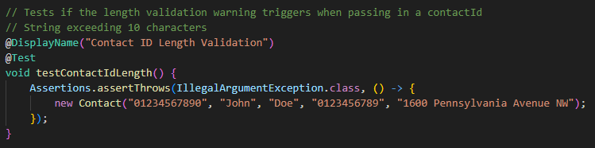
Figure 1-1: Contact Class Id Attribute’s Length Validation
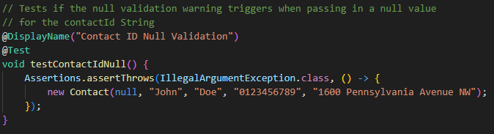
Figure 1-2: Contact Class Id Attribute’s Null Validation
These two tests directly verify that the project correctly handles cases where an over-the-limit string or a null value is used during class instantiation, and that an error is thrown to avoid invalid values from being used. All other attributes in this class, and in the other classes as well, have similar tests that validate one of the requirements for those attributes, ensuring that the requirements for those attributes are properly met within the project. Additionally, some requirements are directly correlated with specific methods across the various classes. For instance, again, three classes share a similar requirement, in which a method must instantiate a new object and append it to a list. These three classes, ContactService, TaskService, and AppointmentService, all include a method that must accept specific parameters, use those parameters to instantiate their respective objects, and append them to a list. This aspect tests to ensure it is functioning properly, and the TaskService's associated test is shown in Figure 2-1.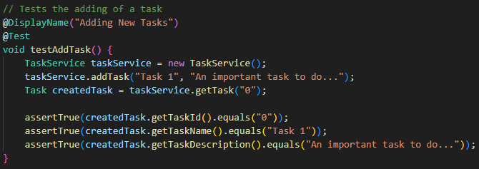
Figure 2-1: TaskService Class Adding New Task Test
The requirements specifications define this test's criteria, and all other tests share this trait, so every test created and run for this project is directly based on a client requirement, ensuring the project aligns with their desires and needs. In the end, the JUnit tests were all created based on the requirements provided by the clients, and each requirement has an associated test to ensure that the project includes the client's expectations.
Using the project requirements as test criteria made it easier to test and ensure that each client requirement was properly met. Still, it was equally important to create these tests in a way that not only validated the project requirement but also the project's code. To ensure the project was functioning properly, some requirements included multiple tests to assess the different outcomes of a given action, such as removing objects from a list, which could yield two possible outcomes. The three classes, ContactService, TaskService, and AppointmentService, all share a similar requirement, which is the ability to remove objects from a list. Two scenarios are possible: one in which the item is in the list and another in which it is not, and each yields different results. Thus, both branches need to be tested to ensure that the project's code is correct, so that the requirement is properly integrated into the project. Figures 3-1 and 3-2 show the tests from the AppointmentService class that test for both potential outcomes.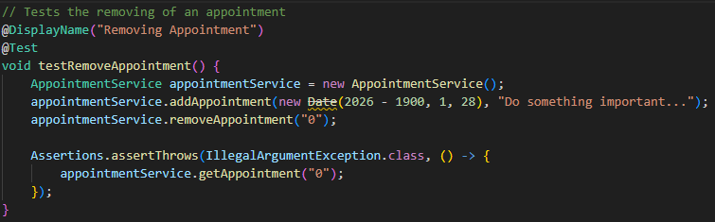
Figure 3-1: AppointmentService Class Removing Item Present in the List Test
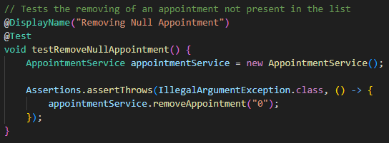
Figure 3-2: AppointmentService Class Removing Item Not Present in the List Test
Testing for both outcomes helps improve project quality by accounting for and properly validating all potential actions. Additionally, testing all possible outcomes improves overall test coverage for the project, which, in turn, helps validate the code. Ensuring each line is run at least once can help validate that the project's code will run without unexpected errors. This project has an over 80% coverage rating, as shown in Figure 4-1, further validating the code's quality by demonstrating that it executes most of the code without generating unexpected errors.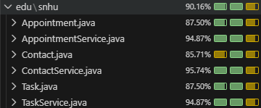
Figure 4-1: Final Project’s Code Coverage Percentage
Overall, in addition to using the requirements as a guideline for the testing criteria, it was equally important to verify that the code executed properly by validating most of it across the different tests to ensure it ran without unexpected errors.
Using JUnit tests made creating and rerunning the project's tests more straightforward. JUnit tests primarily excelled at automatically running each test consistently, making it easier to catch errors and confirm that the code is working. For instance, the biggest benefit this aspect had for the project was its ability to highlight specific tests that produced incorrect outcomes or unexpected errors, so they could be fixed to ensure the code runs properly. All test files included the assertTrue method, which was used to confirm that a comparison was valid, and in most cases to confirm that a specific string matched an attribute of an object. An example of this is in the ContactServiceTest file, specifically the testAddContact test, which verifies that the firstName, lastName, phoneNumber, and address attributes within the Contact object are properly stored and retrieved using the object's methods, as shown in Figure 5-1.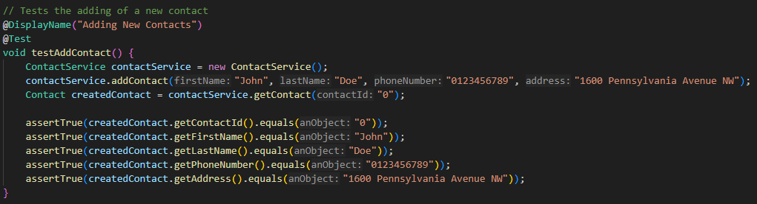
Figure 5-1: ContactServiceTest’s Adding New Contact Test using the assertTrue Method
Using this method made it easier to validate the project's code and ensure it executed as intended without unexpected errors. Rather than manually confirming it, JUnit tests validated it autonomously, enabling these tests to be rerun multiple times without issues or excessive time requirements. By far, the JUnit tests were exceptionally helpful in creating and running tests, allowing tests to be written in a way that validates the code and tests the associated requirement, and to be rerun in the same manner as many times as necessary.
In addition to ensuring that the code was correctly programmed, other strategies were implemented to ensure that the code was efficiently created by avoiding repetitive code. Rather than rewriting the same code for use across multiple features or even tests, methods or functions were created to contain reusable code that could be easily called upon, making the testing process more straightforward and the code easier to understand in general. The three service Java files, ContactService, TaskService, and AppointmentService, all shared a similar practice in which they each contained a method that retrieved a specific element from the array list used to store their respective objects. Instead of repeatedly writing a loop to iterate through the array list in multiple places to obtain the desired element, this method was created and called in the necessary places, drastically reducing the total code needed for the project. The method for the TaskService class is shown in Figure 6-1.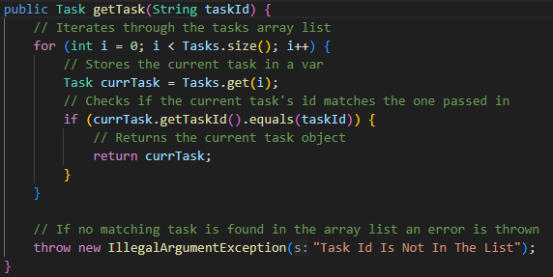
Figure 6-1: TaskService’s Repeatedly Used getTask Method
As Figure 6-1 shows, using methods or functions to encapsulate repetitive code allows the project to call the method in the various places it is used, resulting in a single line within these other methods rather than 7 lines in every instance it is called. This reduction helps ensure the code is efficiently constructed, making any necessary changes to this snippet easier since they only need to be made in a single place. Overall, the use of methods and functions within the class and JUnit tests highlights the project's avoidance of repetitive code and makes it easier to manage and troubleshoot, thanks to reusable functions.
The testing techniques used in this project were essential, given the type of testing required. These techniques, automation and white-box testing, were both used to ensure that the project was executing as intended, that all features were properly included, and allowed these tests to be done autonomously. For the latter, automation was an important testing technique that enabled the use of specific software to consistently rerun specific tests, making the entire process more straightforward. Having the ability to quickly rerun tests after making a change to the project made it easier to stay on top of any issues that arose from those changes. Still, white-box testing was another important testing technique that emphasizes tests that validate the code written for the project. It was essential for all tests to verify that the intended requirement was properly implemented. Still, the tests needed to verify that the code itself was functioning properly as well. As Hambling et al. state, white-box testing focuses on a plethora of coding aspects, specifically it ensures that "each statement in the code of a component is executed at least once… that each decision in a component is exercised and behaves as expected…" (Hambling et al., 2019). The characteristic of white-box testing is that tests check nearly all lines of code within the project to ensure they execute as intended and that each component is properly operational. This characteristic was highly helpful in ensuring that all aspects of the project functioned without unexpected errors, rather than focusing solely on integrating the requirement. While it is essential to ensure the requirements are integrated, failing to ensure the project's code executes properly would result in a problematic project with a plethora of bugs. In the end, the use of automation and white-box testing techniques helped with test creation by making it easier to rerun tests consistently and efficiently, and to focus test criteria on validating requirements and the project code.
While unnecessary for this project, other testing techniques were also considered but ultimately excluded due to the project's requirements and the necessary tests that needed to be performed. Of these testing techniques, the most notable is manual testing, which involves having tests performed manually by a dedicated entity rather than software. The main benefit of performing tests manually is that it removes the need to create tests, such as JUnit tests. It makes it easier to test human interaction aspects, since recreating or mimicking them through automated tests can be difficult. Still, another testing technique that was excluded from this project was black-box testing, as the requirements were directly related to how the system needs to operate, such as how it should be coded and structured, as opposed to how it should function, such as perform or handle human interaction. As the PractiTest Team details in their work, the main characteristic of black-box testing is that tests focus solely on "[t]he inputs received by the system and the outputs or responses it produces…" (PractiTest Team, 2024). Rather than testing the internal code to ensure it is functioning properly, this testing technique focuses solely on verifying that the feature works from the user's perspective. This shift in focus can help ensure the project is functioning as intended for users, which is a high priority for any project, as a poor user experience can make it hard to use. In the end, manual testing and black-box testing are useful testing techniques for validating the user experience and are helpful for most projects.
All techniques mentioned, automation, manual, white-box, and black-box, all serve specific purposes and have useful benefits for all projects. For instance, automated testing can help rerun tests consistently whenever changes occur, validating those changes. Instead of manually running potentially hundreds of tests multiple times, automation can expedite the process and make it easier to catch bugs by rerunning tests consistently. Manual testing is arguably as useful in projects as it enables tests to be conducted without first programming them. Additionally, it is exceptionally useful for tests that need to account for human interactions and mannerisms to validate user interactions and responses, as mimicking these human characteristics can be difficult or time-consuming in automated tests. Aside from concerns about how testing needs to be performed, tests also need to account for what they will primarily focus on. The white-box and black-box testing techniques are helpful in this regard, and they allow test criteria to be focused on a specific aspect of the project. In terms of white-box testing, it shifts the focus of test criteria towards validating the internal structure and all branches of the code. This focus allows the project's code to be validated and properly tested, ensuring no unexpected errors occur. In contrast, black-box testing takes a more abstract approach and shifts the focus of test criteria to testing the project's output with specific inputs. Instead of validating that the project's code is operating as intended, this technique tests the project from the user's perspective by verifying that the expected output occurs when a specific input is provided. Regardless of the differences in testing techniques, they all serve useful purposes in their own ways, making them essential methods to use in any project.
Even though the work on this project was performed as both a developer and a tester, different mindsets were necessary for the different processes. As a developer, the focus was on structuring the code to make it easier to read and understand, to support bug testing and troubleshooting later, and to ensure that any other developer could understand and work on this project if necessary. In contrast, the testing mindset shifted thinking about the issues housed within the project and potential issues that could occur during use. While caution was taken to avoid creating issues with irreversible consequences, such as attempting to delete an important file or using the project to overwrite data, the project was pushed to its limits by deliberately creating errors or issues when using it. In multiple test classes, such as AppointmentTest, ContactTest, and TaskTest, the test uses the method that intentionally throws an error to validate that the project handles it appropriately. 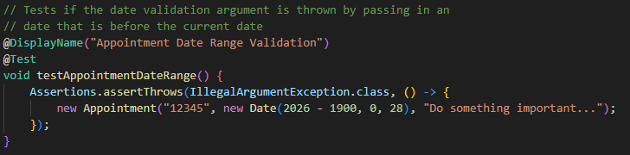
Figure 7-1: Appointment Test Class Date Range Validation
Even though the main purpose of any project is to avoid generating errors in the code, it is still essential to test how the project will handle them if they occur, to ensure it remains functional and usable even if one occurs. Thus, even though the project was created with caution in generating and handling errors, testing ignored this caution and ensured that the project could handle them in the inevitable instance that they occurred for a user. Additionally, knowing how the project was coded made these tests feel necessary, given the many potential issues that could occur even in the perfect environment. Knowing how many classes were interconnected and how reliant many of the classes were on external libraries made it even more essential that the project handled and accounted for these expected and unexpected errors. Overall, caution was critical during the development phase, but it had to be set aside during testing to assess how the project would handle unexpected errors.
Bias will always be present, regardless of who performs testing for a project. However, testing one's own code can introduce more bias due to the connection, so careful consideration is needed. In this case, the developer acted as the tester, so there was a risk of greater leniency and oversight, since one often views one's own work more favorably. One of the best examples of this situation is present in the setter functions of the various classes, in the form of an untested exception that is thrown if the passed-in parameter fails to meet certain criteria. While the criteria match the values specified in the class's initial constructor, it is still separate code that should be tested to ensure correct functionality. Still, in this project, while these setters are run, the exception they throw when the criteria are invalid is never tested, which could be a problem if the developer failed to copy the logic from the construct properly. An example of one of these setters and its similar logic to the constructor is shown in Figures 8-1 and 8-2, which display the Contract class's setAddress method and its constructor, which includes a similar check.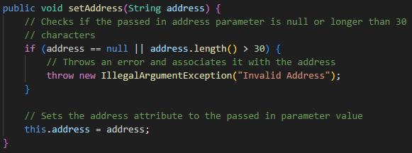
Figure 8-1: Contact Class setAddress Method
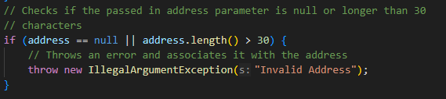
Figure 8-2: Contact Class Constructor’s Address Parameter Check
While this check is the same as the one in the constructor, which is already tested, it is still a separate line of code. The decision not to test it separately shows bias, as the developer believed the code had been properly copied and that the additional test was unnecessary. This bias towards believing in one's skill and the inability to make mistakes could have led to an issue if the check were incorrectly copied. Even a simple error could have led to a major issue that would have negatively impacted the project, so it is necessary to avoid bias as much as possible when working as a tester. Still, steps were taken to avoid this bias as much as possible. Other instances within the project show an attempt to limit bias by including specific checks to ensure that code was written properly, even when it appeared simple and easy to create. An example of this can be found in the various service test classes, specifically in the AppointmentServiceTest, where a test is performed to validate that removing a task is properly handled even when the list is empty, as shown in Figure 9-1.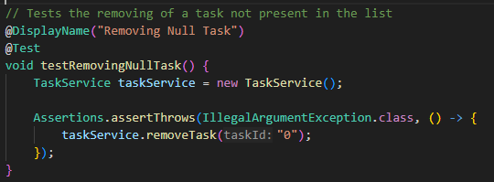
Figure 9-1: AppointmentServiceClass Test for Removing from an Empty List
Ensuring that even the simplest code is properly handled is essential to a project's proper functioning, and it is important to put aside bias and test code properly regardless of who the developer is. In the end, bias will be present in every project, but it is essential to reduce it as much as possible, especially when a developer is testing their own work.
Discipline is essential in all aspects of life, especially when writing code and tests, as failing to maintain a standard can lead to wasted effort on a project. Structuring both code and tests and ensuring they are easy to understand and can be worked on by multiple developers and testers is especially important in larger projects. Failing to maintain a standard can make it difficult for new developers or testers unfamiliar with the project or a specific section of it to work on or use it in their own section of the project. If discipline is ignored, developers would have to spend unnecessary time trying to make sense of hard-to-read code to understand how to use it effectively. Additionally, even the developer who created the code would find it difficult to understand how to fix an issue or add a new feature in the future, as they would likely forget how the code works and need to refresh their memory. Testers share a similar sentiment, as creating hard-to-understand or comprehend tests can lead to testers being unsure about what requirements or criteria specific tests are associated with, leading to a lot of confusion. Taking the time to create well-structured and easy-to-understand code and tests can reduce the complexity and time to understand them by a large amount. Cutting corners when it comes to writing code or tests may save time in the short term, but it will inevitably lead to a stall as difficulties understanding and working with them begin to build. In this project, a good example of effective code construction and ease of understanding is evident in the various classes, as using separate classes helps encapsulate specific code. Rather than having a large page listing all the various attributes and methods within the project, it is separated into different classes so that all related information and logic are near one another. Structuring the code in this manner helps new developers understand how to structure their work as they advance and makes it easier for them to investigate and understand the project's various classes. An example of this practice is the AppointmentService class, where it is easy to see which attributes and methods are available to the class, as shown in Figure 10-1.
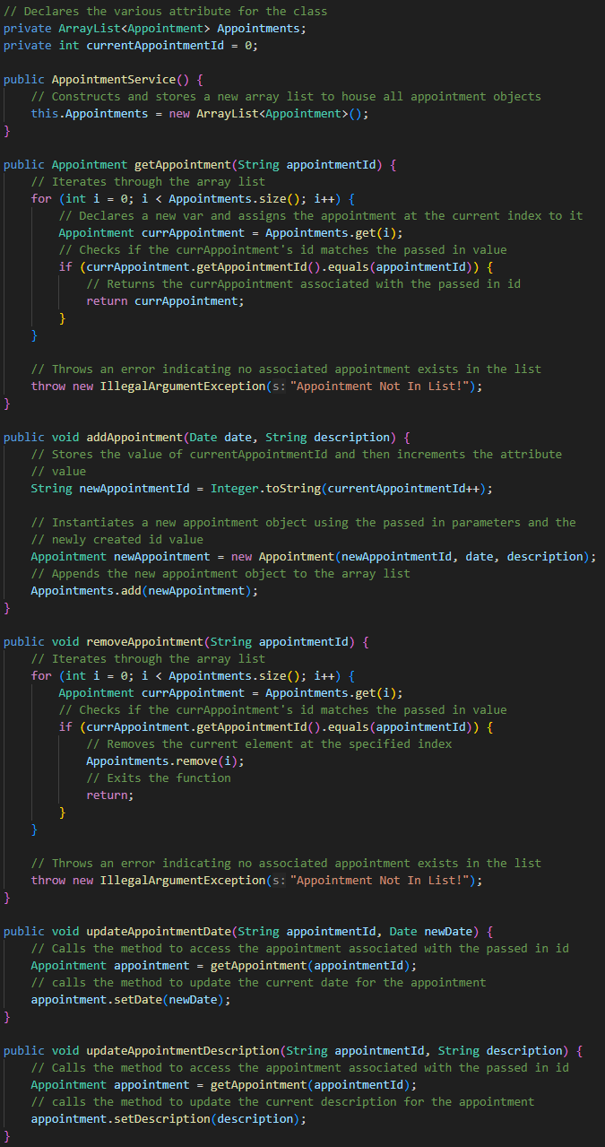
Figure 10-1: AppointmentService Class and its Various Attributes and Methods
Combining all related logic and information into a single class file makes it easier to work with and understand how this class functions. Instead of being overwhelmed and having to jump around to determine the flow of data and logic, having all related information and logic on a single page will make it easier to manage all the different parts of the project. Maintaining discipline by setting standards for code and test construction helps ensure technical debt does not occur, as it encourages careful consideration be taken when designing code and tests. While it will take some upfront time and require planning of how to structure the project, it will help reduce the potential for technical debt in the long run by ensuring that all parts of the project are easy to understand and manage. Similar to how important planning is before coding the project or creating tests for the project, taking the time to plan the structure for both the code and tests for the project can help ensure that all developers and testers are on the same page and that every aspect of the project is similarly structured in instances where others need to interact with them. Overall, discipline is important in developing and testing because it ensures tests and code are easy to understand and that new developers or testers can understand them as well, helping reduce the potential for technical debt on a project.

References
Hambling, B., Morgan, P., Samaroo, A., Thompson, G., & Williams, P. (2019). Software testing :
An istqb-bcs certified tester foundation guide - 4th edition. BCS Learning & Development Limited.
PractiTest Team. (2024, March 4). Black Box Vs White Box Testing. PractiTest.
https://www.practitest.com/resource-center/article/black-box-vs-white-box-testing/

